Entity Relationship Modeling Continued 1
Definitions 1
Independent (Strong) Entities 1
Weak Entities 1
Derived entities (ie. Link table) 2
Weak (Non-identifying) Relationship 2
Strong Relationship 2
Attribute Types 3
Relationships 3
Relationship Degree (N-ary relationshiops) 5
Unary relationship 5
Binary relationship 5
Ternary relationship 5
Examples of Relationship Degree 5
Unified Modeling Language 6
Class Diagram 6
Class 6
Visibility 7
Associations (Relationships) 7
Multiplicity 7
Association Name 8
Direction 8
Inheritance 8
Aggregation 9
Composition 9
Association Class 9
Class diagram sample 10

Entity Relationship Modeling Continued
Last class covered the entity relationship diagram as the cornerstone of data modeling. Ideally, your data model should capture the business rules of the organization to describe the data in a manner that preserves entity and referential integrity.

Definitions
To finish defining our foundation for the ERD, here are some final definitions:

Independent (Strong) Entities
Independent entities are the database Kernel (this entity stands on it’s own) and do not depend on other entities for their existence.

Weak Entities
- are existence dependent. Ie. Room entity vs. building entity.
- Cannot exist without the related entity
- primary key is derived from the primary key of the parent entity
Weak entities are denoted by an entity surrounded by a border.
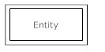
- this is the consequence of mandatory cardinality.

Derived entities (ie. Link table)
- are
- existent dependent on two or more tables
- many to many relationships become associative tables with at least two foreign keys
- may contain its own attributes
- foreign key identifies each associated table
- three options for primary key:
1. composite of foreign keys of associated tables if unique
2. composite of foreign keys and qualifying column
3. create a new simple primary key
(nulls are not allowed for Fks contained in a PK)

Weak (Non-identifying) Relationship
- One entity is existence-independent on another
- PK of related entity doesn’t contain PK component of another entity
- A weak non-identifying relationship is represented in an ERD diagram with a dashed line
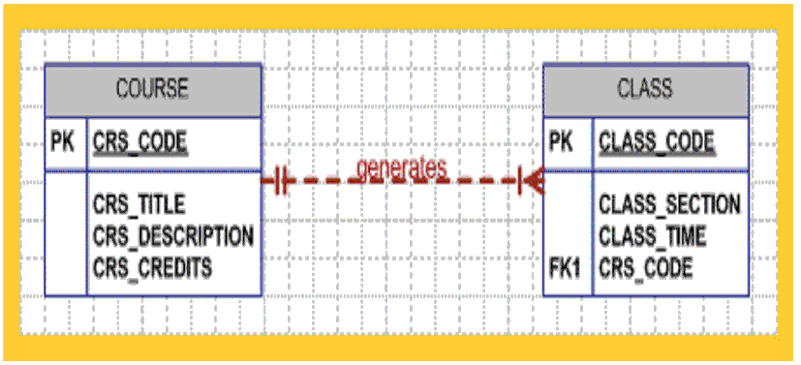

Strong Relationship
- A relationship between weak entity set and identifying owner
- PK of weak entity contains PK component of identifying owner entity
- A strong relationship is denoted with a solid line.
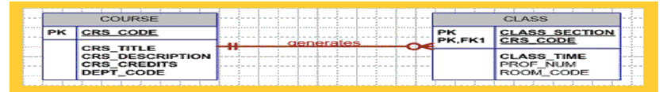

Attribute Types
Single-valued attribute (simple attribute)
- only a single, atomic value allowed
Multi-valued attribute
- This is not to be confused with a composite attribute which is a combination of more than one attribute.
- A multi-value attribute can exist when there is more than one value for each attribute instance. Ie. An education level attribute might have several values. Ie. BComm, Arts, Comp Sci. You could handle this by creating separate fields like address1, address2 or phone1,phone2,phone3 etc. Or you can create a separate table such as an education level table. Then you’d need a link table to bridge the employee with different education levels.

Derived Attribute
-An Attribute whose value may be calculated (derived) from other attributes
-ie. Age can be calculated by subtracting the birthdate from the current date
-Need not be physically stored within database
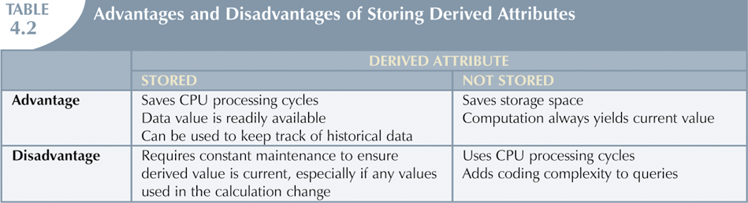

Relationships
Relationships are the glue that holds the components of an E-R diagram together. They are an association that exist between entities to support a business need.

Connectivity
Connectivity describes the relationship classification (ie. 1:M)

Cardinality
- Expresses minimum and maximum number of possible occurrences for each entity instance.
- Established by business rules
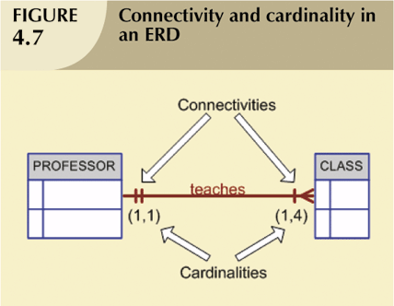

Optional participation
One entity occurrence does not require corresponding entity occurrence in particular relationship.

Mandatory participation
One entity occurrence requires corresponding entity occurrence in particular relationship.

Here’s an example of optional participation. It says only one professor can teach a class. The professor may teach between 0 and 3 classes.
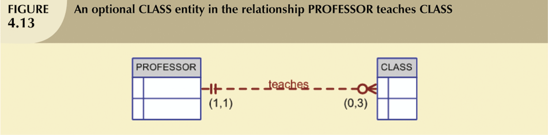
Here is a mandatory relationship between course and class. For each instance of a course, at least one class must exist.
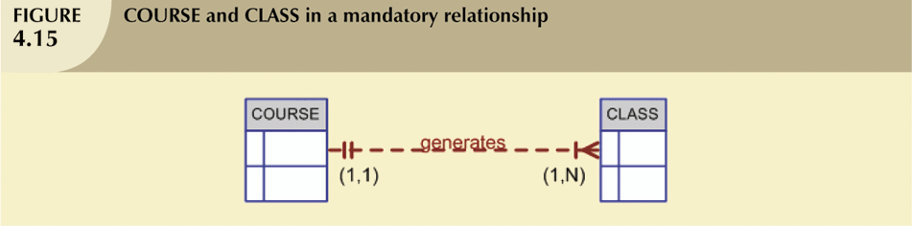

Relationship Degree (N-ary relationshiops)
Indicates number of entities or participants associated with a relationship

Unary relationship
Association is maintained within single entity

Binary relationship
Two entities are associated

Ternary relationship
Three entities are associated

Examples of Relationship Degree
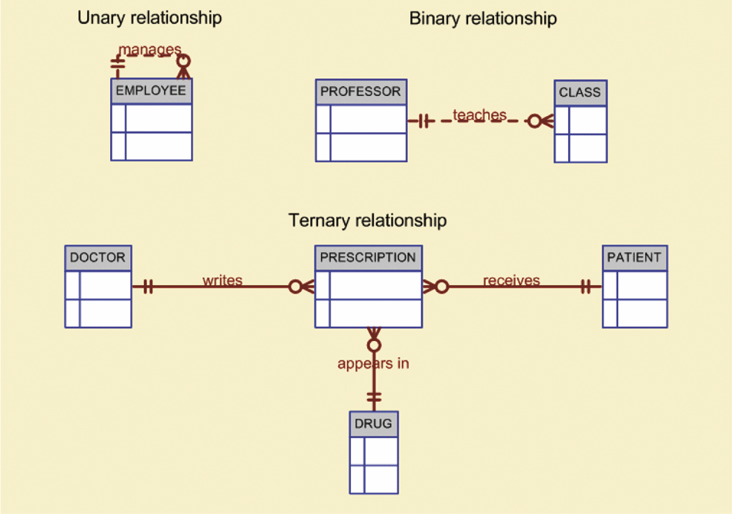
Here’s view of a recursive relationship data
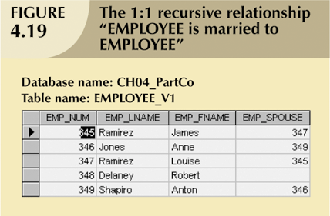

Unified Modeling Language
Unified Modeling Language (UML) is an "object modeling" technique. UML is not designed specifically for data modeling but rather it has been extended for modeling, analysis, and design of data systems.

UML is becoming increasingly more common in systems design but still UML is not the dominant form for relational database design. Even so, UML is a popular and useful alternative that offers strong advantages where object oriented development is being used for systems development.

Class Diagram
The class diagram is UML’s equivalent to the ERD. It shows relationships between objects. Basically, the class diagram functions and looks very similar to the ERD. However, due to the object oriented background of UML, there are many class diagram notations that go beyond the scope of standard data modeling.

Class
A class is UML’s equivalent to an entity. An object is an instance of a class. For example, a blue print is used to build a house. The blue print is the class and the house is the physical instance or object of the class. A class is a collection of similar objects. Attributes and methods are used to describe the class. In a class diagram the class is represented by a box. The top part of the box is the class name, the middle portion of the box lists the class attributes, and the bottom portion of the class box lists the class methods.
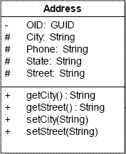
Note: In the RDBMS the methods are already built for us so for our purposes you can ignore the methods.

Visibility
Another key difference with the class diagram is that symbols are placed before the attributes and methods to represent visibility. Since in this course we are not involved with programming the database we can omit these visibility symbols. For our needs we can assume the attributes are always visible.

+Public (Accessible by any class)
#Protected (Accessible only in current class and in subclasses)
-Private (Only accessible in current class)

Associations (Relationships)
A relationship is called an "association" in the object-oriented world. Rather than using graphic symbols, all the information on a UML association is conveyed by characters.

Multiplicity
Multiplicity refers to the number of instances of one class that relate to an instance of another class. Multiplicity provides the same information as connectivity / cardinality in ERDs.

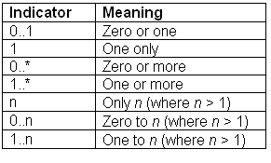
Figure 1 shows that an employee can only hold one position but a position can be filled by 0 to many employees. It also shows that an employee can only work in one division but each division has at least one and possibly more employees.

Association Name
Each association has a name that is written on the association line. (See figure 1)

Direction
Directional awareness is not supported in relational databases. However, you can think of it in terms of foreign keys. If a class uses a foreign key that is a primary key of an associated class it is aware of the related class. If both classes both classes use foreign keys that are primary keys of the other then the association is bi-directional. However, if an associated class does not reference the primary key of the referencing class this association is uni-directional.

Bi-directional associations are represented with a straight line. Uni-directional relationships are represented with an arrow pointing to the class that is unaware of the referencing class.

In figure 1, Position and Employee share a uni-directional association where Position is unaware of Employee but Employee is aware of Position. The association between Employee and Division is bi-directional where both classes use foreign keys that reference the primary key in the other class.
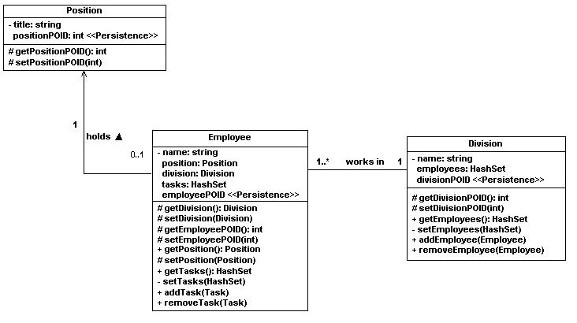
Figure 1

Inheritance
One of the more problematic differences between relational diagrams and UML is inheritance. In an object-oriented model, an object may be derived from a long line of classes. The relational model, on the other hand, is generally flat and does not show the hierarchy behind the entity. The diagram below shows the parent class, payment, denoted with the triangle pointing to it. The child classes are Credit, Cash, and Check. Each child is a different form of payment.
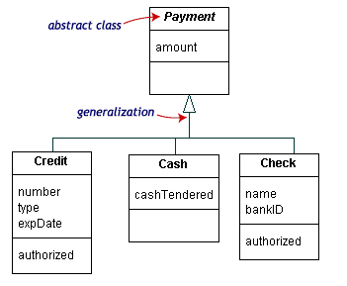

Aggregation
Aggregation shows a ‘has-a’ relationship which occurs when a collection class has an optional association with a strong parent object. If the parent object is deleted the collection of objects can still remain.

In figure 2, if the owner leaves or dies the car remains.

Figure 2

Composition
Composition is like an aggregation but the child object depends on the existence of the parent. They two classes are in a strong relationship. For the example shown in figure 3, if the building is destroyed then the room is destroyed along with it.

Figure 3

Association Class
An association class is like a link table in a many-to-many relationship. In Figure 4, a parcel of land can be owned by many people. A person can own many different land parcels. The ownership class bridges the landparcel class and person class.
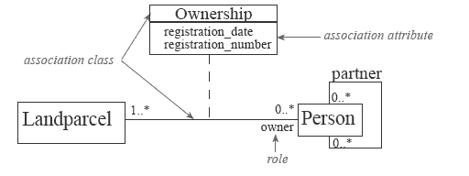
Figure 4

Class diagram sample
To tie everything together, here is a UML class diagram that shows a data model using inheritance, aggregation (collections), direction, and multiplicity.
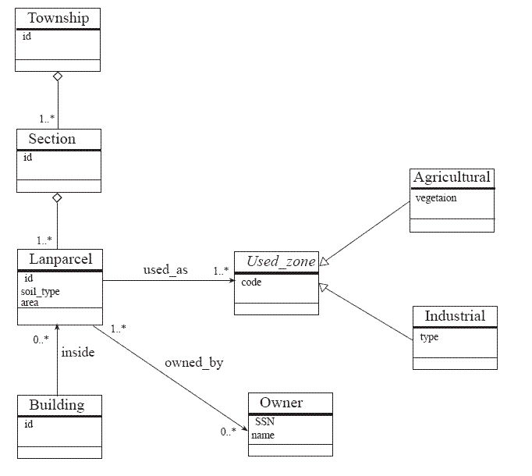

References:
http://www.sedris.org/dm_notn.htm
http://www.sparxsystems.com.au/downloads/whitepapers/Database_Modeling_In_UML.pdf
http://www.inf.udec.cl/~andrea/cursos/SDB2005/e-SDB6/Doc_1_1.pdf
http://www.agiledata.org/essays/mappingObjects.html

